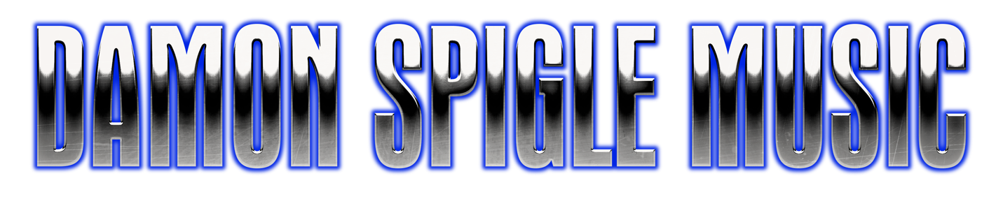 Technical Rider
5 PIECE BAND
Damon Spigle Music in concert requires a professional sound reinforcement system. This system shall be in excellent working order and free of noise or distortion. The system must be adequately rated to provide sound coverage for the entire venue. Proper cabling must be supplied for all equipment listed below. Any substitutions must be approved by the band engineer and management.

FOH Console Must be a minimum of 24 inputs, with 8 groups, 8 auxiliary sends and a stereo house mix; 4 band semi-parametric EQ or better required on input channels (Preferred: MIDAS XL or Heritage series; if not available, equivalent Sound craft, Yamaha, or Allen & Heath) • Ideally, the console should be placed slightly left or right of center stage, approximately three quarters back • Must not be in a booth or enclosure of any kind.

House Signal Processing
• 2 channels of 1/3 octave graphic house EQ left-right
• 4 channels of insertable noise gates
• 8 channels of insertable compressors (Drawmer DL241 or equivalent)
• 2 digital effects processors: 1 Reverb and 1 Delay (TC Electronics, Lexicon, Yamaha) House Loudspeaker System
• 3-way system (including subwoofers) capable of supplying sufficient SPL level to the entire venue (at least 110 dB SPL at FOH), with appropriate crossovers, power amps, equalizers, and cabling • Meyer Sound, L-Acoustics, Adamson, or similar quality (Mackie is NOT preferred)
Stage Monitor System • System should be set-up, rung out, and running prior to sound check
• 5 to 6 wedges with 5 mixes, preferably mixed from separate monitor console on-stage by tour manager • Monitors should be at least 12-inch cone w/horn • Each mix must have one channel of 1/3 octave graphic equalization • Amplifiers must be rated to cleanly drive the monitor system.

Snake / Splitter System • Minimum 24 channel send, 8 channel return snake of sufficient length to reach the front-of-house mix position from the stage.

Venue Sound engineer, or hired sound engineer. Must work with Damon Spigle Music and Perry Music Group, NO EXCEPTIONS!

Mics / Stands / Direct-Boxes / Cables (See input list on next page for further reference) • 2 Shure Beta 58A • 2 Shure Beta 57A • Sufficient microphones to adequately mic the drum kit (preferably Shure Beta series) • 2 tall boom stands, 2 short boom stands, sufficient stands to mic drum kit • 4 DI boxes • Complete compliment of microphone cables • Adequate AC cable to provide power at either side and rear of stage

DAMON SPIGLE FULL BAND stage diagram.
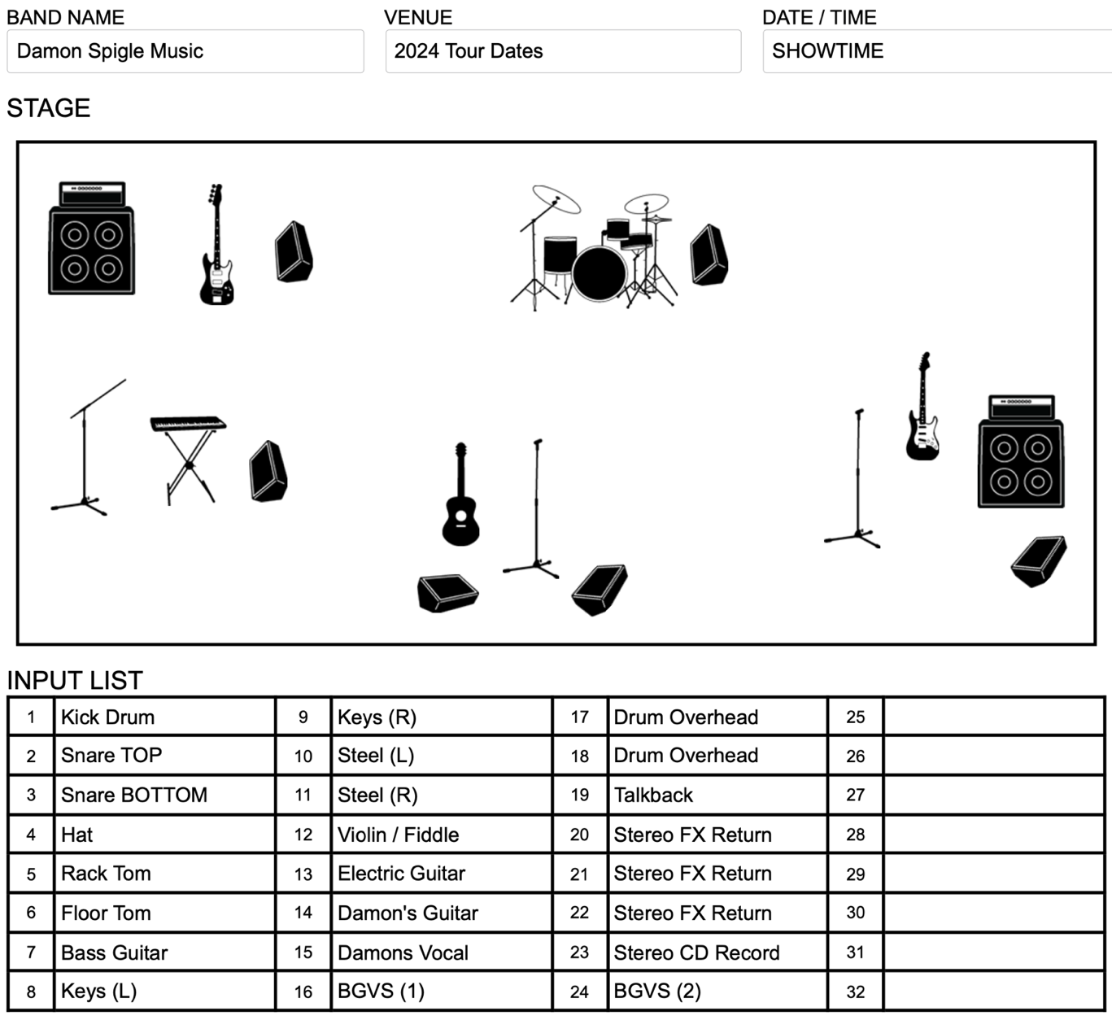
Damon Spigle Music FULL BAND Input List H
- Kick Drum
- Snare Drum Top
- Snare Drum Bottom
- Hat
- Rack Tom
- Floor Tom
- Bass Guitar
- Keys L
- Keys R
- steel L
- steel R
- Violin
- Electric Guitar (Guitar Player Name)
- Acoustic Guitar (Damon)
- Lead Vocal (Damon)
- Backup Vocal (BGVS NAME)
- Drum overhead
- Drum overhead
- Talkback
- Stereo FX return
- Stereo FX return
- Stereo FX return
- Stereo CD
- Background vocal 2
The hospitality rider and a welcoming and helpful promoter and staff are all an essential part of the band putting on the best show possible for your patrons. We would like to thank you for inviting us to perform at your venue.
If you have any questions or concerns about ANY changes to the above rider, please feel free to contact:
Management:
Sound Engineer:
Gary Spigle, By phone @ (606) 669 - 8162 (cell) or via email: gspigle@windstream.net

Tour Manager:
Gary Spigle By phone @ (606) 669 - 8162 (cell) or via email: gspigle@windstream.net

Press: Algorithm Universe
By phone at (615) 719 - 8005 (cell) or via email: info@algorithmuniverse.com

© 2024 Damon Spigle Music / Proudly created by Perry Music Group 2025 ©

